Advanced Computer Networking and Security - 5800

Assignment -8

Local DNS Attack Lab

Name: SAI ROHIT JONNADA

ID :700723743

Task 1

Code for Directly Spoofing Response to User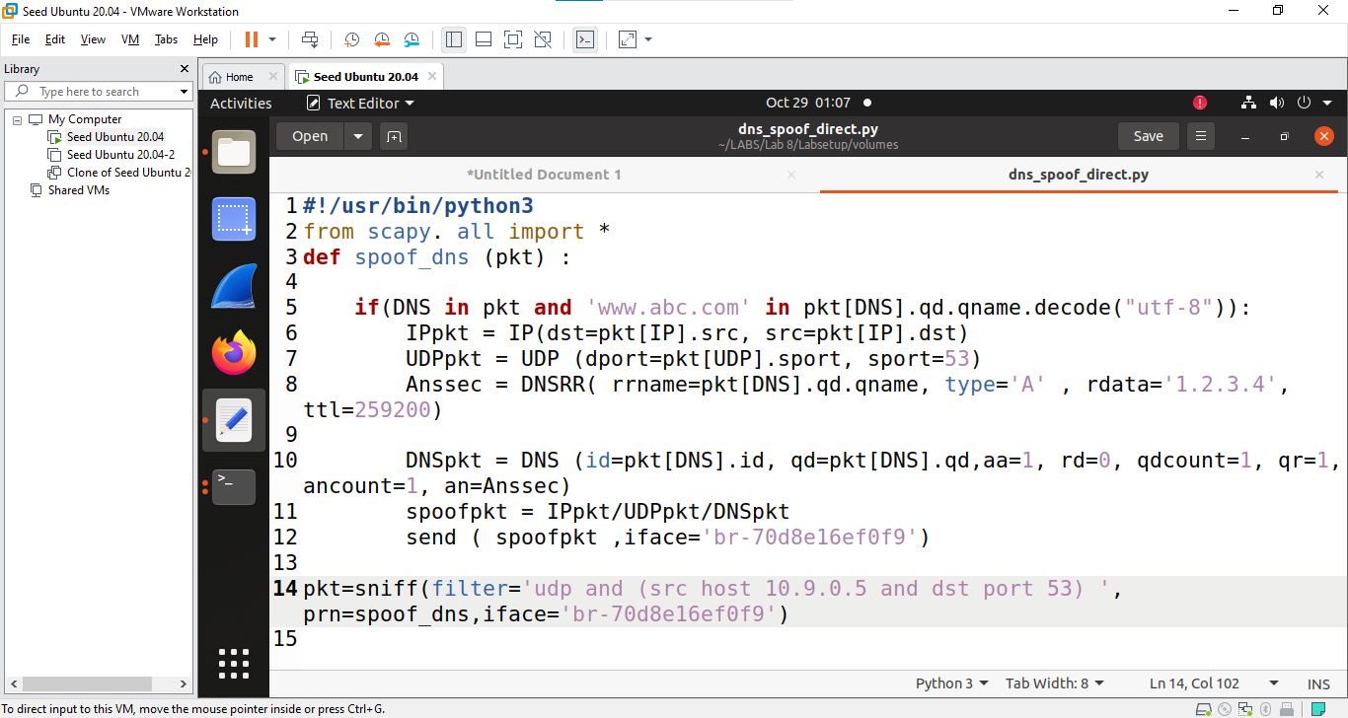

Execution of Code

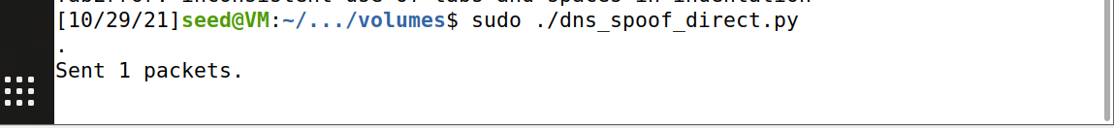

Dig abc.com from user 10.9.0.5

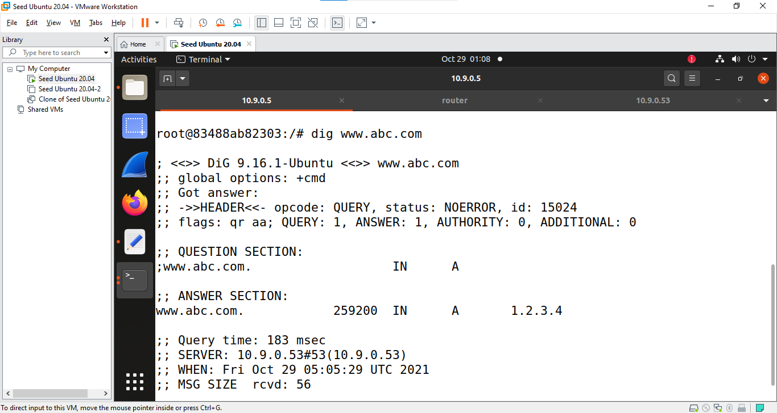

Task 2: DNS Cache Poisoning Attack – Spoofing Answers

Code for Dns Cache posion attack

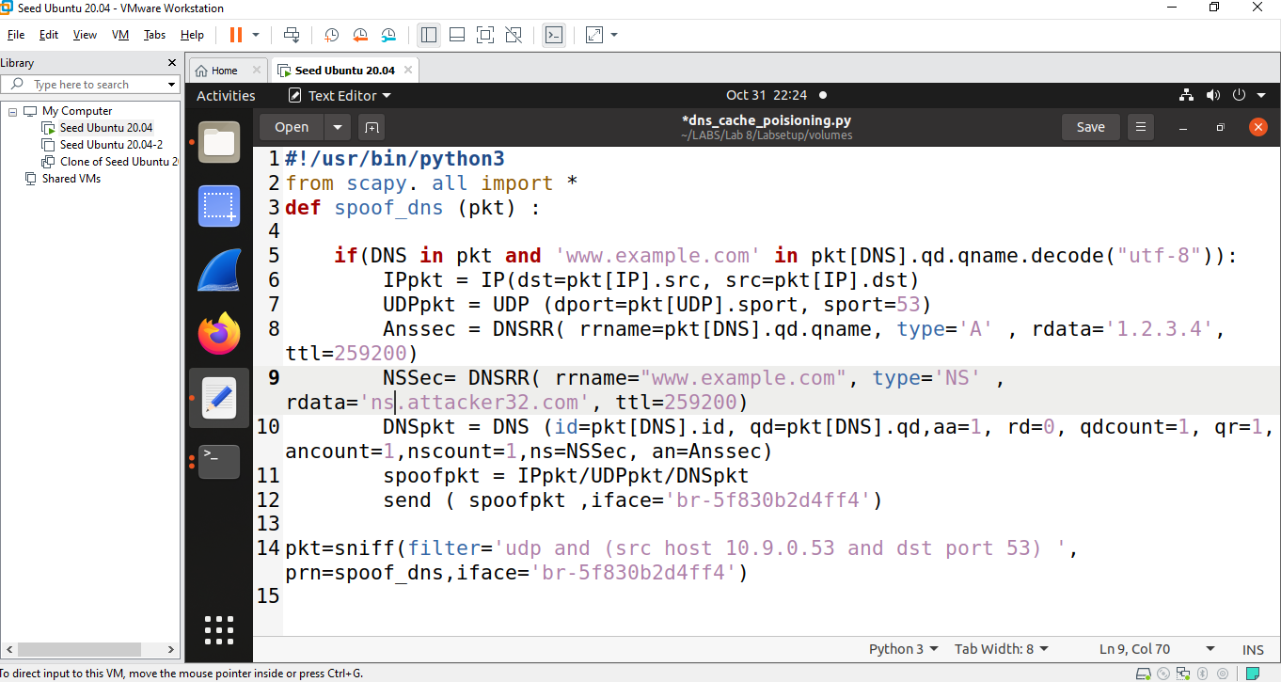

Execution of code

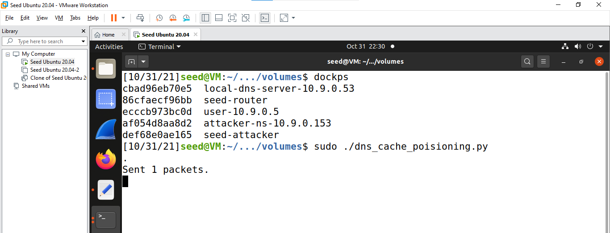

Successfully DNS Cache Poisoning

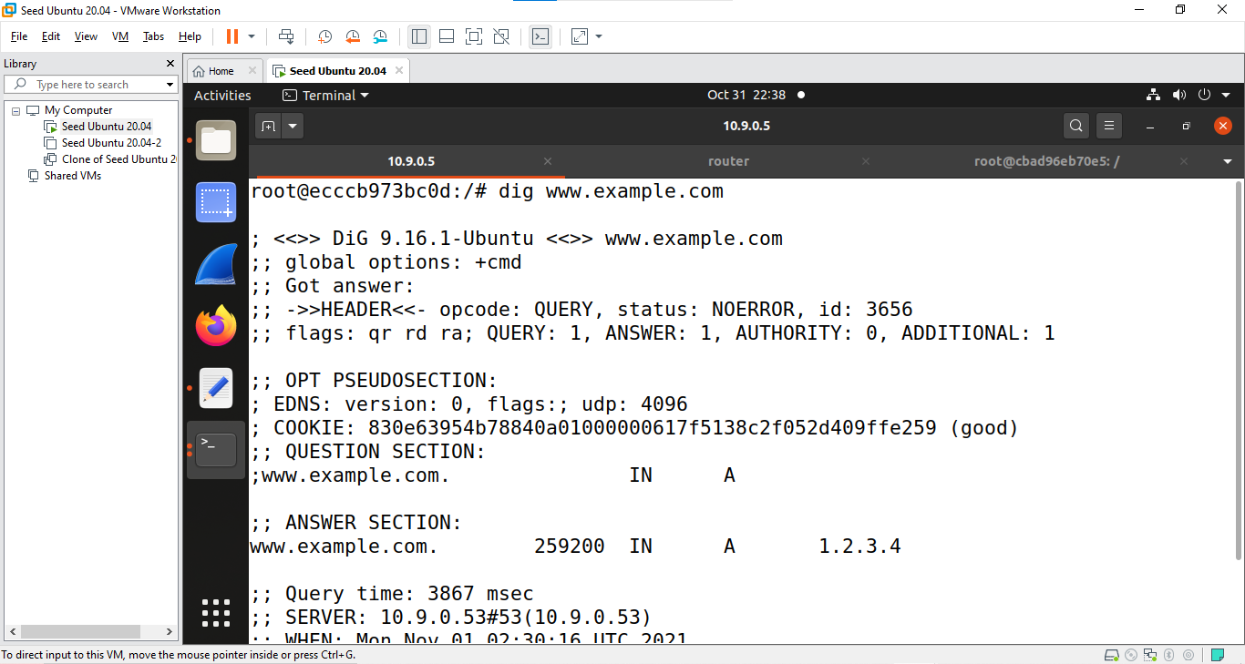

Task 3: Spoofing NS Records

Code For Spoofing NS Records

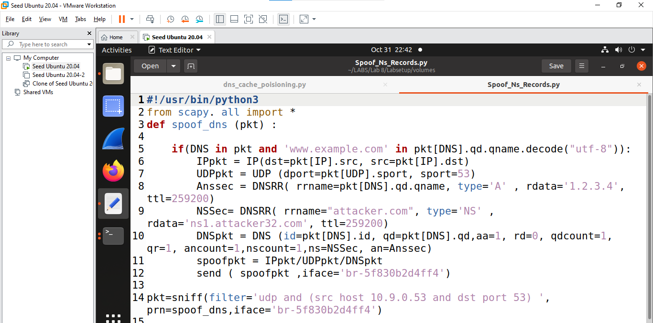

Execution of Code

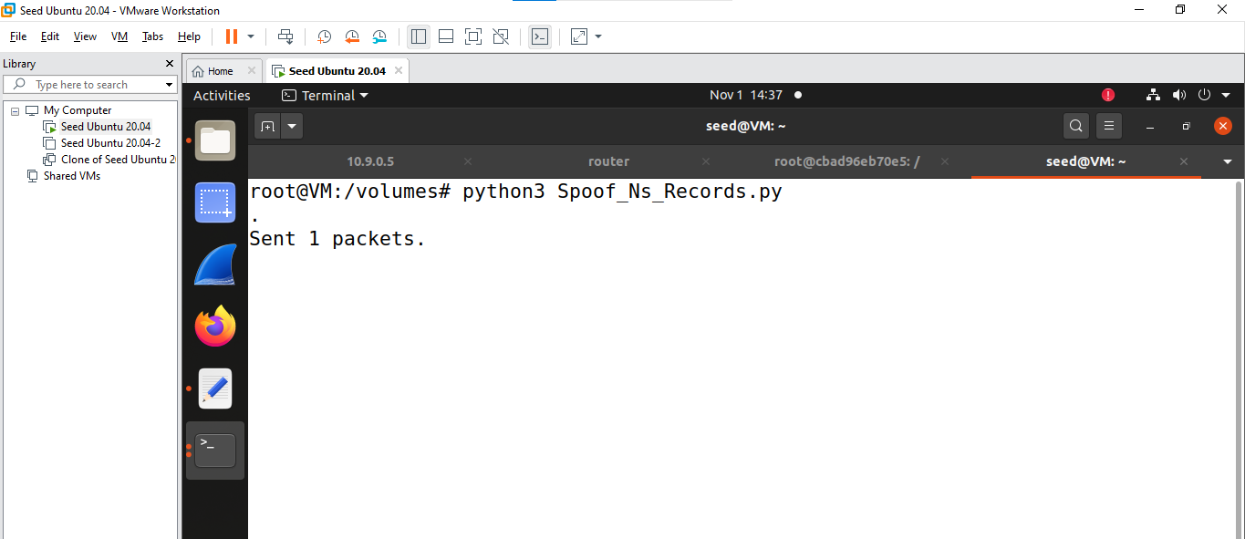

Succesffully Spoofing NS records

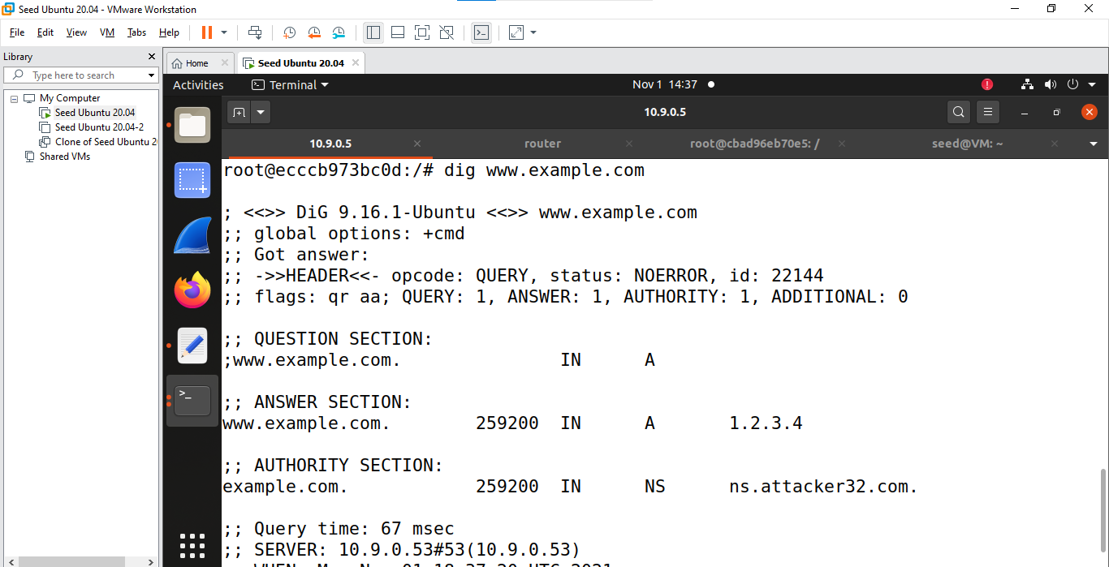

Task 4: Spoofing NS Records for Another Domain

Code

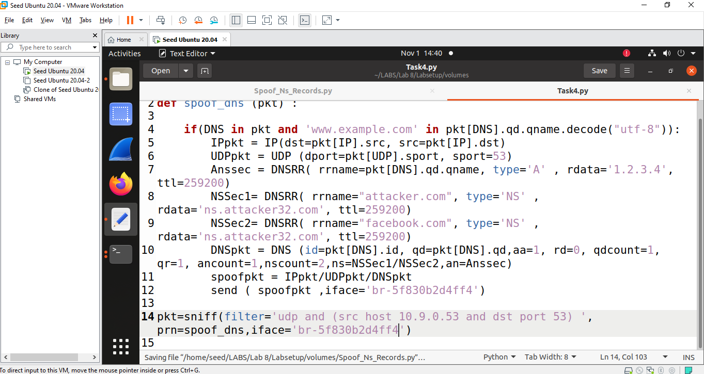

Execution of code

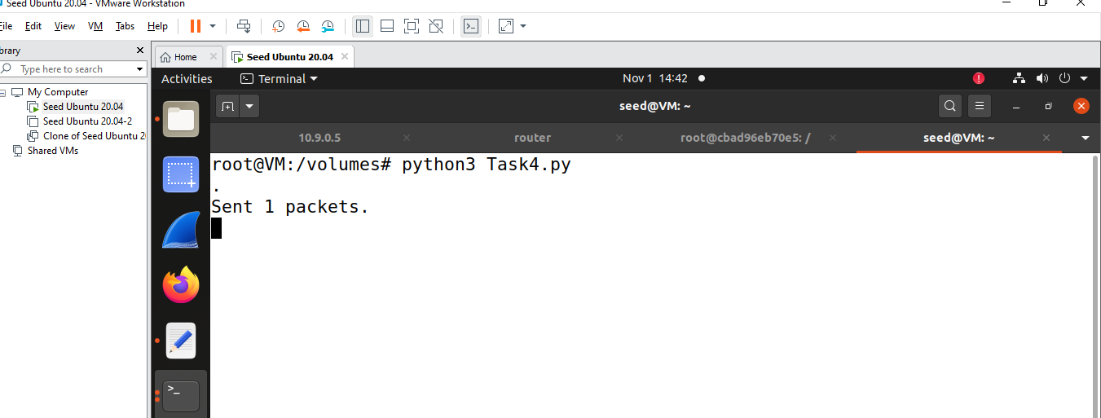

Successfully spoofing NS Records for Another Domain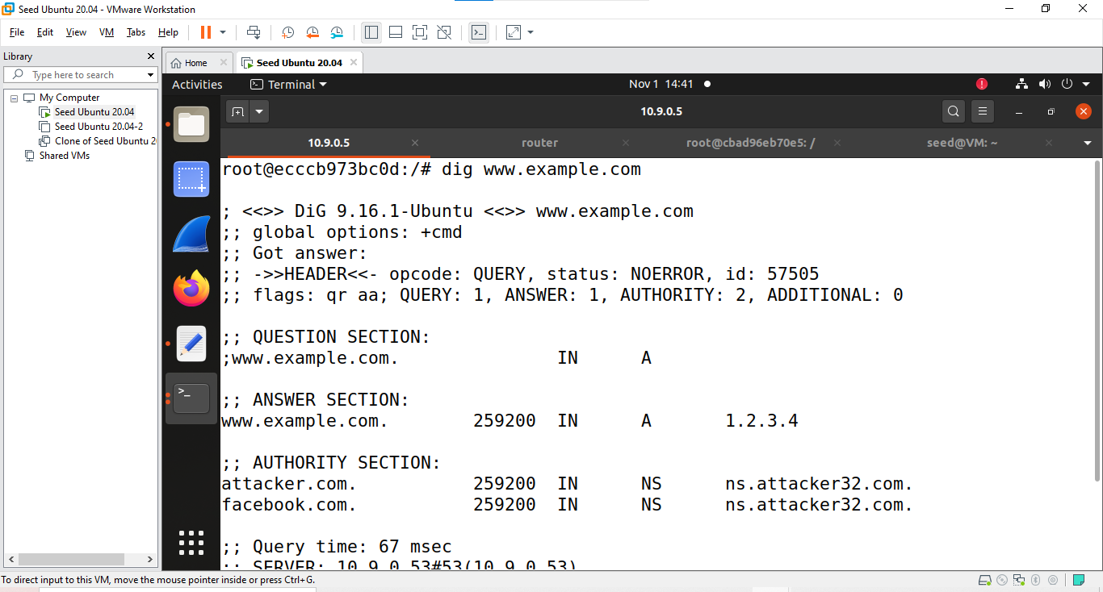

Task 5: Task 5: Spoofing Records in the Additional Section

Code

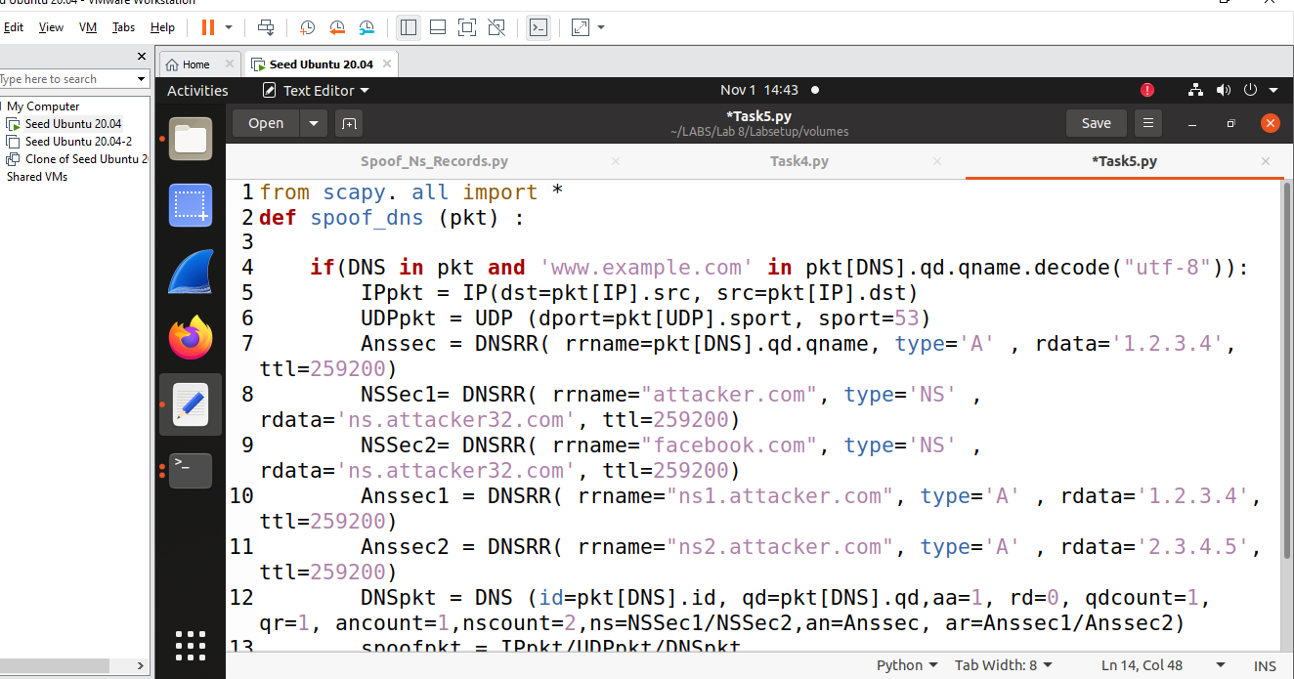

Execution of code

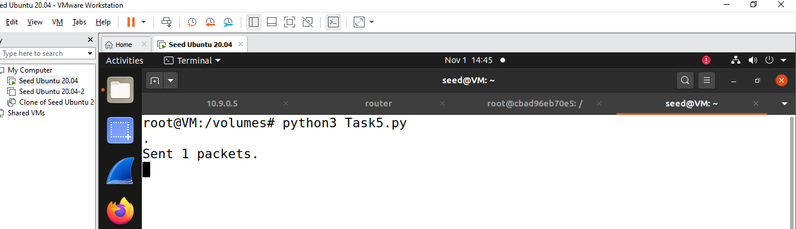

Successfully additional records are added

